2.Design NFA to accept aaaaaa

DESIGN:

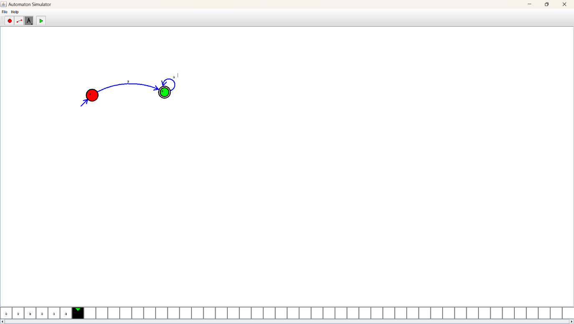

OUTPUT:

